Preconception and Contraceptive Care for Women Living with HIV

Toolkit Request Form
ORDERING
EMAIL to: fxbcenter@sn.rutgers.edu (please include “Preconception Care Toolkit” in subject line and attach this order form)
Joanne Phillips — François-Xavier Bagnoud Center, Rutgers School of Nursing
65 Bergen Street, 8th floor • Newark, New Jersey 07101 USA
Phone: 973-972-9231 Fax: 973-972-4263
CONTACT PERSON  Name:  Organization:  Address  Phone:  Email: | SHIP TO  Name:  Organization:  Street Address:  City, State, Zip:  Phone:  Email:

Number and Title of Tool |  | Quantity Requested
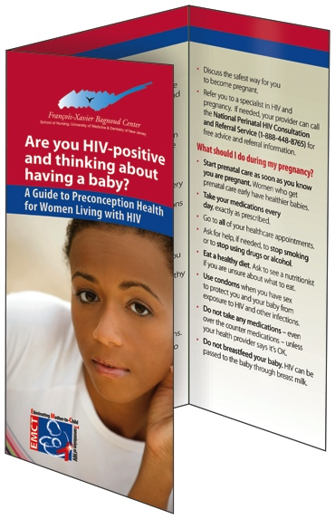 | Tool #1 – “Are You Thinking About Having a Baby?” An informational brochure for patients that defines preconception health and explains the importance of preconception care for women living with HIV.
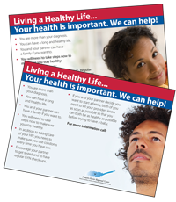 | Tool #2 – “Living a Healthy Life” A postcard for patients that encourages them to take steps to ensure they stay healthy. One side with advice for women and the other side for men.
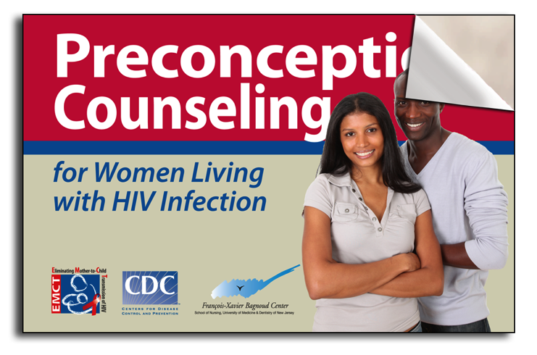 | Tool #3 – “Preconception Counseling for Women Living with HIV” A counseling guide for providers with suggested scripts for discussing fertility desires and preconception care with women of reproductive age living with HIV.
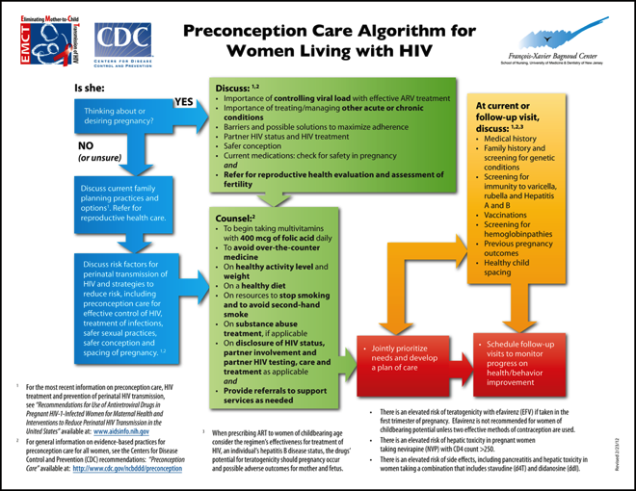 | Tool #4 – “Preconception Care Algorithm for Women Living with HIV” An algorithm for HIV providers showing the components of preconception care for women living with HIV who are of reproductive age
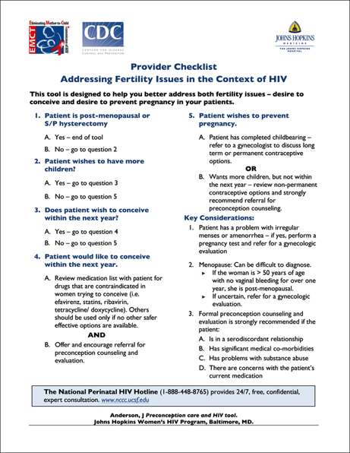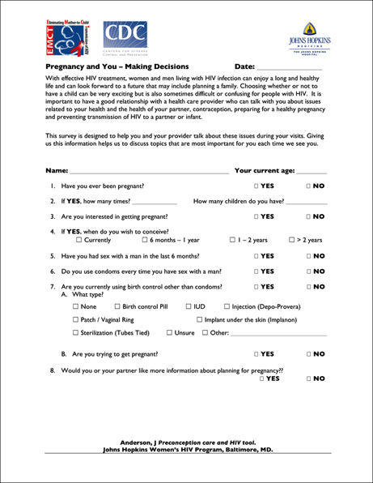 | Tool #5 – “Client questionnaire and provider checklist” This is a two–part tool to support preconception care. The front side is a patient questionnaire that explores fertility desires and basic reproductive history. The back side is a provider checklist to provide guidance on providing basic contraceptive and preconception counseling and care during a primary care visit.
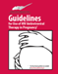 | Tool #6 – “Guidelines for the Use of Antiretroviral Therapy in Pregnancy” (pocket guide) US-based treatment recommendations for antiretroviral therapy to prevent transmission during pregnancy and for infants exposed to HIV.
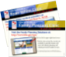 | Tool #7 – “How to Locate a Family Planning Clinic in Your City or State”  “How to Locate a Ryan White Clinic in Your City or State”
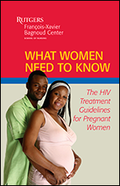 | Tool #8 – “What Women Need to Know: The HIV Treatment Guidelines for Pregnant Women”  An informational booklet for patients that discusses key topics in HIV and pregnancy.
- Electronic copies are also available in PDF format online at:
http://aidsetc.org/aidsetc?page=etres-display&resource=etres-658 OR http://www.fxbcenter.org/resources.html (Scroll down for Clinician Resources)
- Please allow 2-3 weeks for delivery.

